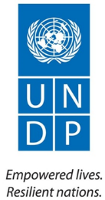
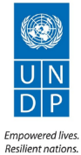

COMMUNITY SECURITY & ARMS CONTROL PROJECT

2016 Quarter One Progress Report
(April, 2016)

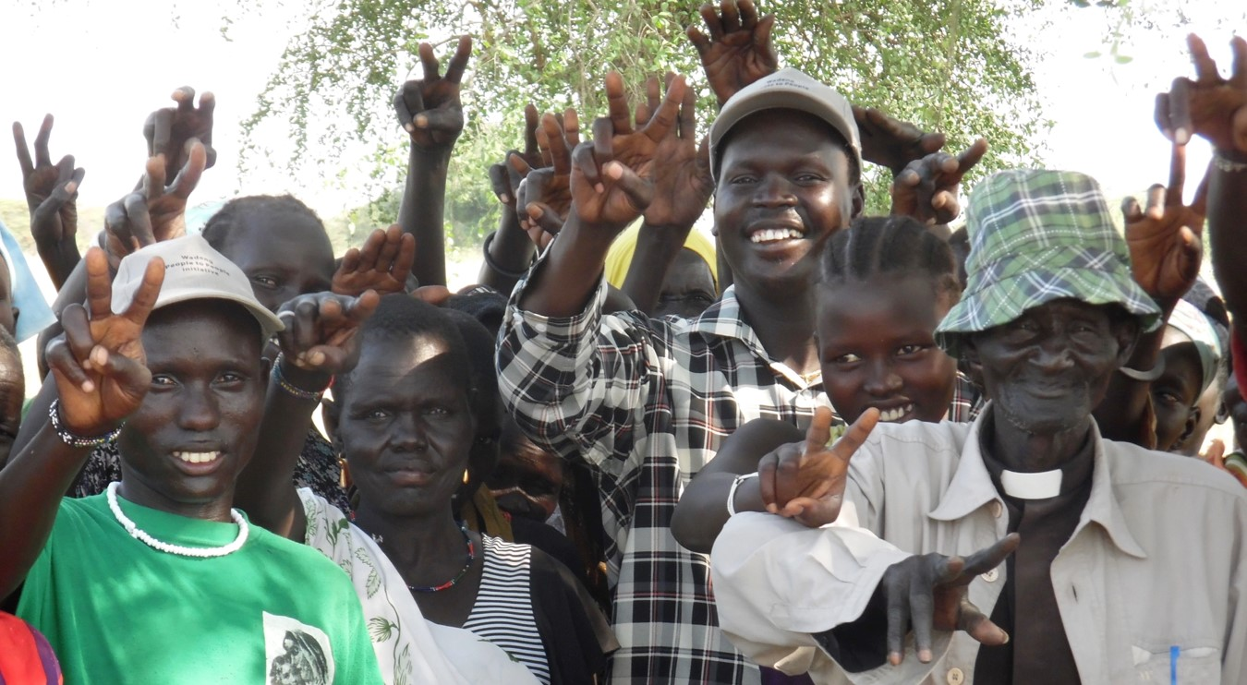
Community members committing to uphold peace and harmony after a peace meeting in Panyanbil, Duk County, Jonglei state, January 2016

Project Summary | Country: South Sudan  Project Duration: January 2014 – December 2016  Annual Project Budget (2016): USD$ 3,046,376.22  Cumulative expenditure: USD 541,421.25  Contact Persons:  Andrew Shuruma  Team Leader, Democratic Governance & Stabilization Unit  Tel. +211 (0) 922 661 010  Email: andrew.shuruma@undp.org  Judy Wakahiu  Project Manager, Community Security & Arms Control  (CSAC) Project  Tel. +211 954 481 103  Email: judy.wakahiu@undp.org
  Donor | Annual budget US$
  DFID | 1,662,910.33
  Norway | 223,713.84
  Sweden | 918,379.05
  Switzerland | 241,373.00
  TOTAL | 3,046,376.22
Responsible Parties: South Sudan Peace & Reconciliation Commission; South Sudan Bureau for Community Security and Small Arms Control; Ministry of Interior and Civil Society Organizations

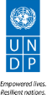
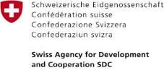
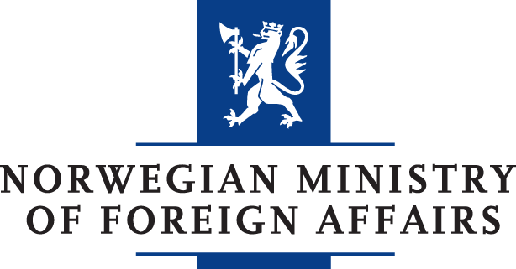
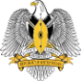
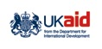
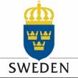
Contents
Acronyms 4
Executive Summary 5
1. Progress towards development results 6
1.1 Progress toward country programme results 6
1.1.1 Country Programme Document (CPD) Output 3.3 The national peace architecture delivers key peace and reconciliation initiatives 6
1.2 Progress toward 2016 annual work plan results 6
1.2.1 Project Output 1: The Bureau for Community Security & Small Arms Control’s capacity is strengthened to advance the agenda for small arms control in South Sudan 6
1.2.2 Project Output 2: Inter-communal stability and relations improved a long common interest in targeted conflict clusters 8
1.2.3 Project Output 3: South Sudan institutions, constituencies, and communities work together for inclusive peace and reconciliation 9
1.2.4 Project Output 4: Operational capacity of county governments in conflict-prone counties improved through infrastructure rehabilitation and provision of equipment 11
1.2.5 Project Output 5: Strengthen civil voice, promote accountability, and engender social cohesion 11
2. Gender Development Results 13
3. Targeting, sustainability of results, strengthening national capacities and South-South and Triangular Cooperation 13
4. Partnerships 14
5. Monitoring and Evaluation 14
6. Challenges/Issues 15
7. Lessons Learnt and Way Forward 15
8. Risks and Mitigation Measures 15
9. Provisional Financial Summary 16

Acronyms

ARCISS | Agreement on the Resolution of Conflict in South Sudan
AWP | Annual Work Plan
BCSSAC | Bureau for Community Security and Small Arms Control
CDC | County Development Committees
CLD | Collaborative Leadership and Dialogue
CPD | Country Programme Document
CSAC | Community Security and Arms Control
CSB | County Support Bases
CSOs | Civil Society Organizations
DFID | Department for International Development
HACT | Harmonized Assessment on Cash Transfer
I4P | Infrastructure for Peace
IDPs | Internally Displaced Persons
M&E | Monitoring and Evaluation
MoF | Ministry of Foreign Affairs
MoI | Ministry of Interior
NBS | National Bureau of Statistics
NPPR | National Platform for Peace and Reconciliation
PMSU | Partnership Management and Support Unit
PoC | Protection of Civilians
RCSAC | Regional Centre on Small Arms Control
SALW | Small Arms and Light Weapons
SAS | Small Arms Survey
SFG | Search for Common Ground
SMARD | Solidarity Ministries Africa for Reconciliation and Development
SSANSA | South Sudan Action Network on Small Arms
SSPRC | South Sudan Peace and Reconciliation Commission
UNDP | United Nations Development Programme
USD | United States Dollars
WAV | Women Aid Vision

Executive Summary

Delayed implementation of the peace agreement, especially the formation of a Transitional Government of National Unity (TGoNU) and implementation of agreed reforms adversely affected project implementation throughout the quarter. Spiralling commodity prices due to exchange rate volatility increased the cost of doing business in the country, affecting most project partners.
UNDP continued working with project partners; South Sudan Peace and Reconciliation Commission (SSPRC) and the Bureau for Community Security and Small Arms Control (BCSSAC) and civil society organisations (CSOs) implementing accelerated communal interdependency initiatives under the small grants mechanism. The following results were realized during the first quarter of 2016:
- Firearms Control Bill was reviewed, harmonized, and consolidated before being presented for a three day public hearing.
- Small arms and light weapons (SALW) proliferation baseline survey commenced with extensive involvement of BCSSAC, the National Bureau of Statistics (NBS), and Geneva based Small Arms Survey Institute.
- Provided space for the communities to interact and strengthen their relationships through wrestling festival in Yirol East, Yirol West, and Awerial counties bringing together over 1,000 participants (30% female).
- Provided platform for key national leaders from government, CSOs, academia, religious leaders, and youth groups to engage on peace and reconciliation through two collaborative leadership and dialogue (CLD) workshops. Participants reflected positively on the workshop, expressing confidence in their ability to peacefully resolve conflicts and move towards peace.
Challenges
- Resource mobilization gap resulted in a budget shortfall amounting to USD 1 million leading to a reprioritization of project activities to create funds for the end line survey.
- Insecurity in Yambio and Maper County hampered project implementation.
Lessons Learnt and Way Forward
- The CSO mapping as well as the evaluation of small grant activities revealed that capacity building should be a key and integrated component of CSO engagement.
- The delay by CSOs to complete project activities within the stipulated timeframe signifies the need to give CSOs adequate implementation time with deeper and consistent engagement to realise results.
Budget and delivery
The current project budget is USD 3,046,376.22. Cumulative expenditure during the first quarter of 2016 was US$ 541,421.25 which represents a delivery of 18%.

Progress towards development results

Progress toward country programme results

Country Programme Document (CPD) Output 3.3 The national peace architecture delivers key peace and reconciliation initiatives
Summary achievement based on CPD output 3.3 targets
CPD output targets | Summary achievement to date | Status
A national and subnational framework for reconciliation and dispute resolution developed and adopted | Two CLD workshops involving key national leaders from security organs, religious groups, civil society organisations (CSOs), women, and youth groups were conducted to impart dialogue, leadership skills and strengthen their capacity to manage conflicts and peaceful dispute resolution. CLD participants have taken ownership of the process and agreed to facilitate a national dialogue on economic challenges facing the country and peacebuilding in South Sudan as a starting point towards a coordinated framework to reconciliation. | Ongoing
A national regulatory framework on small arms and light weapons is endorsed and implementation commences | There was a three days public hearing of the Firearms Bill 2016 in parliament with participation of political leaders, security organs, women leaders, and CSOs under the umbrella of South Sudan Action Network on Small Arms (SSANSA). The bill is expected to be passed in quarter two, and will regulate both civilian and state controlled stockpiles. | Ongoing
Overall status |  | Ongoing

Progress toward 2016 annual work plan results

Project Output 1: The Bureau for Community Security & Small Arms Control’s capacity is strengthened to advance the agenda for small arms control in South Sudan
Summary achievement against 2016 Annual Work Plan (AWP) target
Annual Output Target (2016) | Summary achievement during the quarter | Status
Firearms Control Bill passed | Three days public hearing of the Firearms Control Bill 2016 conducted in parliament with participation of political leaders, security organs, women leaders and CSOs under the umbrella of South Sudan Action Network on Small Arms (SSANSA). The bill, once passed, will regulates both civilian and state controlled arms stockpiles. | Ongoing
Sixteen consultations /awareness on Small Arms and Light Weapons (SALW) control undertaken | Two consultative workshops were conducted involving the parliamentary oversight committee on Security, Defense and Public Order Management and CSOs under the umbrella of SSANSA resulting in a harmonized position to include the State stockpile control measures. | Ongoing
Five international instruments on SALW control ratified | Ratification of the international instruments on SALW control have been put on hold pending formation and functioning of the Transitional Government of National Unity (TGoNU). These instruments are:  - United Nations Arms Trade Treaty;  - Nairobi Protocol for the Prevention, Control and Reduction of SALW in the Great Lakes Region and the Horn of Africa;  - UN Programme of Action on Small Arms;  - International Tracing Instrument and the UN Protocol  - Against Manufacturing and Illicit Trafficking in SALW | Delayed
Ten mid-management positions filled in the Bureau for Community Security & Small Arms Control (BCSSAC) | A chairperson was appointed by the Activing Minister of Interior to head the BCSSAC, ending three years of acting capacity in the Bureau. Seven positions were filled in 2015. | Ongoing
Baseline on small and light weapons in South Sudan conducted | A baseline survey on the extent of SALW proliferation in South Sudan was commissioned. Sampling, identification of enumeration areas, and researchers were completed during the quarter paving way for training of research assistants | Ongoing
Overall status |  | Ongoing

Firearms Control Bill passed
The Firearms Control Bill 2016 underwent three days public hearing by two parliamentary oversight committees; Defense, Security and Public Order Management and the Committee on Justice and Legislation. Political leaders, security organs, women leaders and civil society organization under the umbrella of South Sudan Action Network on Small Arms (SSANSA) actively participated during the hearings. Their collective efforts led to the reinstatement of provisions on State controlled stockpiles that had been struck off by the Council of Ministers. The bill will be presented in parliament for third and final readings in quarter two.
Sixteen consultations/awareness on SALW undertaken
Two consultative workshops on SALW were conducted. Parliamentary Oversight Committee on Security, Defense and Public Order Management and CSOs under the umbrella of SSANSA participated in these consultation and influenced the inclusion of State stockpiles in the bill. Stakeholders to the consultations considered prior allegations of arms leakages that were traced to state stockpiles. It was also emphasized that for national security interests, the database for State stockpiles would be exclusively managed by the mandated State security institutions (the Sudan People’s Liberation Army (SPLA) and the National Security Bureau).
Five international instruments ratified
Ratification of the international instruments on SALW was put on hold pending formation and functioning of the Transitional Government of National Unity (TGoNU). With UNDP’s technical support, the BCSSAC held follow up meetings with the Ministries of Foreign Affairs and Interior on the importance of ratifying and domesticating the international instruments.
Ten mid-management positions filled in BCSSAC
A substantive chairperson was appointed by the Acting Minister of Interior to head the BCSSAC. This was immediately followed by discussions between the BCSSAC and the Ministry of Public Service to initiate the recruitment process of the vacant positions. As a result, the terms of references for all the vacant positions have been developed and the BCSSAC has also been advised to compile a comprehensive list of their recruitment needs for review by the Ministry whether the required positions are within the public service nominal register.
Baseline on small and light weapons in South Sudan established
With UNDP’s technical and financial support, the BCSSAC, Small Arms Survey Institute (SASI), National Bureau of Statistics (NBS) launched a national baseline survey on the extent of small arms and light weapons proliferation in South Sudan. Enumeration sites in Greater Upper Nile, Greater Equatoria, and Greater Bahr el Ghazal were identified for primary data collection. The findings of the baseline survey will provide a basis for evidence based Small Arms and Light Weapons policy formulation and programming in South Sudan.

Project Output 2: Inter-communal stability and relations improved a long common interest in targeted conflict clusters
Summary achievement against 2016 Annual Work Plan (AWP) target
Annual Output Target (2016) | Summary achievement during the quarter | Status
Two thousand and sixty participants reached with messages on peace and reconciliation through public information and outreach campaigns | Messaging will commence in quarter two. Forty interactive radio drama episodes were developed to facilitate interactive radio discussion among the citizens on community security, peace and reconciliation. | Ongoing
Two community infrastructures to accelerate peaceful co-existence | Civil works have commenced on two stadiums in Awerial and Yirol West. | Ongoing
Overall status |  | Ongoing

Two thousand and sixty participants reached with messages on peace and reconciliation through public information and outreach campaigns
Forty interactive radio drama episodes were developed in English and Juba Arabic for dissemination through various radio stations from quarter two. The episodes focus on; peaceful co-existence, forgiveness, rebuilding South Sudan, Sexual and Gender-Based Violence (SGBV), and the dangers of SALW, among others. It is anticipated that dissemination of these peace messages will contribute towards strengthening community cohesion and promote culture of peace and tolerance for divergent views.
Two community infrastructures to accelerate peaceful co-existence
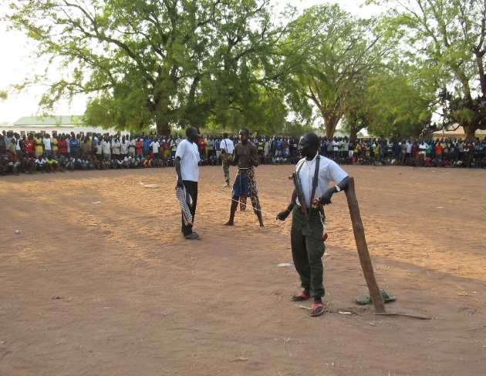
Following identification of wrestling as a socio–cultural connector for Yirol West, Yirol East, and Awerial communities in 2015, the project commenced construction of two wrestling stadiums in the three communities. The project team engaged local authorities and clarified their roles in the construction and maintenance of facilities to enhance local ownership and sustainability of the facilities.
As construction of the stadiums continues, communities are already engaging in wrestling activities. Over 1,000 participants (30% female) from Yirol East, Yirol West and Awerial County participated in the wrestling festival organised by UNDP’s implementing partner - Solidarity Ministries Africa for Reconciliation & Development (SMARD) in Yirol Town. The event provided space for the communities to interact and strengthen their relationships.
Wrestling event in Yirol West, February 2016

Project Output 3: South Sudan institutions, constituencies, and communities work together for inclusive peace and reconciliation
Summary achievement against 2016 Annual Work Plan (AWP) target
Annual Output Target (2016) | Summary achievement during the quarter | Status
Four engagements meetings between South Sudan's religious leadership and political/security actors. | Two CLD workshops were conducted to develop leadership skills of South Sudan's religious, political and security leadership and strengthen the capacity to manage conflicts and resolve conflicts peacefully. | Ongoing
Twenty five actions undertaken to support a common forum of dialogue between conflicting communities | Three concept notes for the promotion of dialogue between conflicting communities were developed, finalized and approved for implementation from quarter two. | Ongoing
Overall status |  | Ongoing

Four engagements meetings between South Sudan's religious leadership and political/security actors
Two workshops were conducted: a) one day refresher workshop for 16 participants (six women) from the previous CLD workshop in August 2015 to reflect on their vision and reconfirm their commitment to the importance of dialogue; b) four-day workshop for a second CLD cohort composed of 21 participants (five women) from government, civil society, faith based institutions, and academia. The two cohorts were brought together on the last day of the four-day workshop and jointly developed an action plan under the theme “A new beginning towards a united and prosperous South Sudan that embraces our diversity as one people, one nation”. As per their own reportage, participants of the two CLD workshops gained new dialogue and leadership skills and strengthened their capacity to manage conflicts.
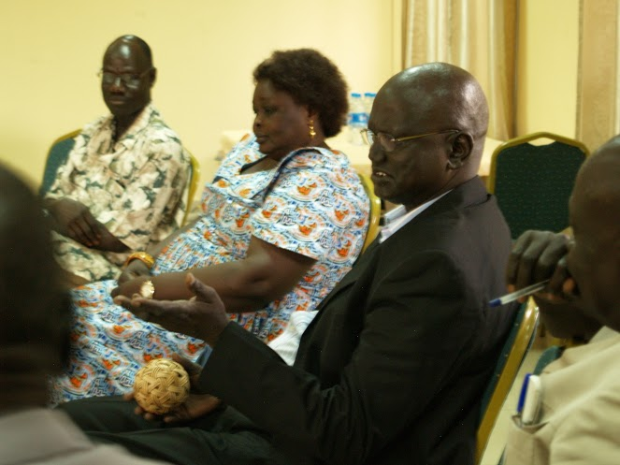
One of the participants had this to say about the workshop experience, “I found out information I did not know before and now my relationship with my colleague is no longer the same as it was.”
Participants during a dialogue session at the one-day CLD refresher workshop, February 2016
The participants of the two CLD workshops demonstrated strong ownership of the CLD process by forming a CLD Core Group that is leading the development of a long-term CLD strategy. Under the leadership of the South Sudan Peace and Reconciliation Commission, the core group agreed to facilitate a national dialogue on economic challenges facing the country and peacebuilding in South Sudan targeting national and state level decision makers.
Twenty five actions undertaken to support a common forum of dialogue between conflicting communities
Three concept notes on; a) the peace actors and partners’ quarterly meeting; b) mediation training targeting women, and c) the round table dialogue on strategic re-positioning of the National Platform for Peace and Reconciliation (NPPR) in the current South Sudan discourse were developed, finalized and approved for implementation from quarter two.

Project Output 4: Operational capacity of county governments in conflict-prone counties improved through infrastructure rehabilitation and provision of equipment
Summary achievement against 2016 Annual Work Plan (AWP) target
Annual Output Target | Summary achievement during the quarter | Status
Thirteen County Support Bases (CSBs) handed over to County governments | Preparations to hand over two CSB portals in Tombura and Awerial East counties were initiated through consultations with UNMISS and the county commissioners. The counties will be handed over in the second quarter.  Construction of two CSB portals in Boma and Maper counties was suspended due to the untenable security situation. | Ongoing
One hundred and fifty four (154) Community Development Committees (CDCs) trained in basic management and administration | Commencement of trainings planned for the second quarter | Delayed
Eighty-percent of CSBs with increased humanitarian, development, or community engagement | Completed CSBs around the country continued to house development and humanitarian agencies providing services in their respective localities. | Delayed
Overall status |  | Delayed

The project team will continue to engage the donors on resolving the issue of two inaccessible portals and 11 other portals that were completed but could not be handed over due to insecurity.

Project Output 5: Strengthen civil voice, promote accountability, and engender social cohesion
Summary achievement against 2016 Annual Work Plan (AWP) target
Annual Output Target (2016) | Summary achievement during the quarter | Status
Twenty CSOs supported to engage in local peace and reconciliation initiatives | Selection of partners to continue with peace and reconciliation activities that were initiated in 2015 is ongoing. | Ongoing
Civil Service Organisation (CSO) coordination forums and capacities strengthened | Civil society mapping finalized and capacity gaps identified. | Ongoing
1 policy brief produced per quarter | Juba University Center for Peace and Development Studies was selected to conduct a series of public lectures at state level and produce policy briefs. Lectures are expected to commence from the second quarter.
Two youth and three women peace initiatives launched | Consultation meeting with women and youth undertaken to identify peace initiatives. The initiatives will be launched in quarter two. | Delayed
One bi-monthly public lecture held | Not conducted pending conclusion of the contracting process for Juba University | Delayed
Overall status |  | Ongoing

Twenty CSOs supported to engage in local peace and reconciliation initiatives
Working through three CSOs, UNDP extended critical peace and reconciliation messages to Yirol, Awerial and Terekeka; Mvolo, Rumbek East and Yirol West; and Magwi and Pageri counties.
The peace and reconciliation initiatives generated important results:
- Peace conferences enabled community members to identify strategies to address key conflict drivers in their communities. For instance, cattle movement was identified as fuelling conflict in Maridi, and communities resolved to tackle the challenge and prevent escalation of conflicts. Ten peace conferences were held and brought together 6,276 community members in Duk, Ayod, Kapoeta South, Maridi counties and the Malakal Protection of Civilian (PoC) site.
- Community peace dialogues contributed to shifts in perspectives and attitude changes of participants. For example, during an inter-generational dialogue in Mangateen, Central Equatoria State, one internally displaced person (IDP) commented: “Dialogue is leading to changes in attitudes among elders and youth and is vital in achieving peace and unity at home. As I participated in this dialogue I am impressed, intrigued and moved by the dialogue that I heard between the old and the young, the Nuer and the Dinka communities”. Sixteen dialogues were conducted in Bor Town, Twic East, Malakal PoC, Bentiu PoC, Mundri West, Mundri East, Mvolo, Kapoeta East, and Juba involving 2,315 community members (936 women)..
Community volunteers at a training for participatory educational theatre during a trust building exercise, Mairidi, March 2016
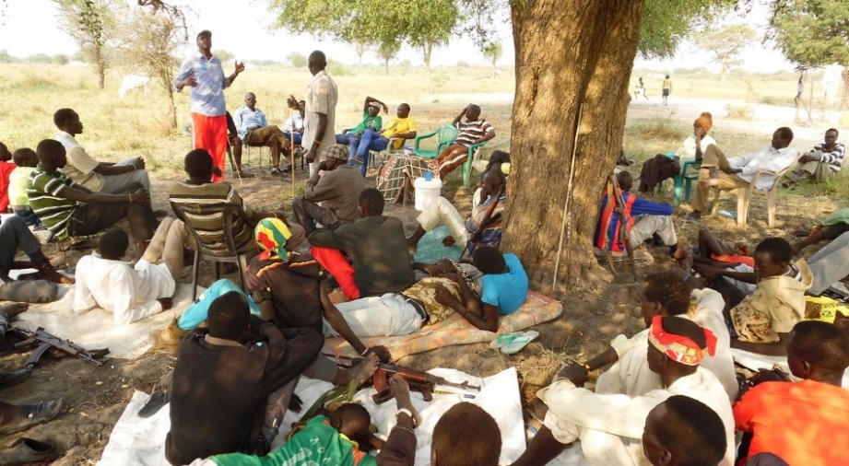
- Peace engagements facilitated by community peace committees enabled the exchange and movement between the different ethnic groups, especially IDP camps and PoC sites. Peace committees (formed in 2015) continued to operate during the first quarter in Ayod, Bor Town, Malakal PoC, Twic East, PoC Bentiu, Kapoeta South and in Juba IDP camps and PoC sites.
Cattle camp youth during a peace workshop in Duk County, Feb 2016

CSO Coordination forums and capacities strengthened, 1 policy brief/quarter
HACT assessment is underway in order to assess the financial capacity of Juba University. Once the assessment is finalized, the concept note for public lectures will be finalized jointly with the Centre.

The report on the mapping of civil society organizations at national and state level, which was conducted in 2015, was finalized. The findings of this mapping will inform CSAC’s engagement with CSOs and thereby strengthen CSO coordination forums and capacities.

Gender Development Results
Gender results | Evidence
During dialogue sessions conducted in Pageri and Magwi attended by 1000 people (30% women), the paramount chief and the area local administrator resolved to offer equal opportunity to women participants to raise their views on how best to address the conflict dynamics within the communities | Search for Common Ground dialogue report

Targeting, sustainability of results, strengthening national capacities and South-South and Triangular Cooperation

  - Targeting
Target groups | Needs addressed | Evidence
Youth | Positive outlets and inter-communal interaction activity provided for youth to increase and enhance their interaction with each other through a wrestling festivals. | Solidarity Ministries for Africa Reconciliation (SMARD) Programme report

  - Sustainability
Results achieved | Sustainability
The dialogue sessions conducted in the conflict clusters had extensive engagement of the local authority administrators and paramount chiefs who mobilized communities to turn out in large numbers | The use of local leaders, who are the custodians of relations in the communities to mobilize the communities for dialogues gives the process legitimacy and much needed ownership and adherence to the resolutions reached

  - Strengthening national capacity
Results achieved | Institution | National capacity strengthened
Two CLD workshops, and one- week long training conducted for 37 (nine women) senior national leaders | SSPRC, CSOs, Parliamentarians, Human Rights commission, Sudd Institute, Ministry of Defense Juba University, Islamic Council, Council of Churches | Participants self-reported enhanced ability to resolve conflict.

  - South to South and Triangular Cooperation
Country | Type of cooperation
- Cote d’ Ivoire | The Regional Centre for Small Arms, based in Kenya, supported the BCSSAC to participate in an experience sharing workshop in Cote de I’voire where BCSSAC presented a paper on tackling the challenges of SALWs in a post conflict context. This effort is part of UNDP’s support to strengthen South Sudan’s small arms control frameworks and strategies.

Partnerships
- UNDP partnered with three CSOs; Solidarity Ministries Africa for Reconciliation (SMARD), Women Aid Vision (WAV), and Search for Common Ground (SFCG) to deliver peace and reconciliation initiatives in Yirol, Awerial and Terekeka; Mvolo, Rumbek East and Yirol West; and Magwi and Pageri counties.
- In partnership with the BCSSAC and the National Bureau for Statistics (NBS), UNDP contracted the Small Arms Survey Institute to conduct a baseline study on the SALW proliferation in South Sudan. NBS led the sampling and identification of the enumeration areas while the BCSSAC facilitated security clearance and approval from relevant government institutions to conduct the baseline. The baseline findings will provide a solid basis for evidence based policy formulation and programming in South Sudan.

Monitoring and Evaluation
The project developed a monitoring and evaluation (M&E) plan to systematize M&E activities during the year. Working with the UNDP communications team, the project will also develop human interest stories focussing on project impacts. M&E activities conducted during the quarter:
M&E activity | Key outcomes/ observation | Recommendation | Action taken
Review and reflection workshop for grant -receiving CSOs | Key results of small grant activities reviewed and recommendations made for second round of small grants | Extension of some of the grant agreements is recommended. The workshop format should be considered as a tool for feedback; capacity development is required for CSO staff to improve the quality of interventions | Recommendations presented to and considered by the UNDP’s Small Grant Evaluation Committee

Challenges/Issues

- Due to resource mobilization gap that resulted in a budget shortfall amounting to USD 1M, the project was forced to drop some activities in the 2016 AWP to create funds for the end line survey.
- Due to insecurity in Yambio area, one of the CSOs undertaking peace dialogues was not able to achieve planned results and complete project activities as per the project document.
- The insecurity in Maper County made it impossible to access the County Support Base. This continues to affect the completion of the CSB civil works construction.

Lessons Learnt and Way Forward
- The CSO mapping as well as the evaluation of small grant activities has shown that capacity building should be a key and integrated component of CSOs engagement.
- The delay by CSOs and implementing partners to complete the agreed activities within the stipulated timeframe has shown that for meaningful engagement there is need to give CSOs adequate time and equally allow deeper and consistent engagement if results are to be realized

Risks and Mitigation Measures
Risks | Mitigation Measures
Delayed formation of the Transitional Government of National Unity delays implementation of project activities such as a national dialogue on the economy and peacebuilding by SSPRC and ratification of treaties by MOI and MOFA. | The project will continue to hold refreshers to keep engaging CLD members so that momentum is sustained.
Lack of coordination between different actors involved in the implementation of chapter 5 of the ARCISS leads to a lack of a coherent approach and a lack of clarity with regards to comparatives roles of the various actors including the NPPR. | Preparations are underway for a round-table discussion on the implementation of chapter five of the ARCISS.

Outputs / Activity Result |  | Annual Budget (US$) | Expenditures (Jan-Mar) | % Expenditure
 |  | A | C | C/A*100
Output 1: The Bureau for Community Security & Small Arms Control (BCSSAC)’s capacity is strengthened to advance the agenda for small arms control in South Sudan
Activity Result 1.1. | Core management and administration functions of the Bureau are strengthened | 174,358.00 | 12,210.07 | 7%
Activity Result 1.2. | National policies and legislation on small arms control are developed and passed | 566,773.00 | 6,110.18 | 1%
Output 1 Sub-total |  | 741,131.00 | 18,320.25 | 2%
Output 2: Conflict-sensitivity and community participation integrated into early recovery and development programming to improve the local stability and peacebuilding environment in three conflict clusters across Jonglei, Lakes and Eastern Equatoria States
Activity Result 2.1. | National institutions undertake public outreach efforts through public awareness raising, peace promotion, community security and national unity messaging | 37,141.00 |  | 0%
Activity Result 2.2. | Inter-communal interdependencies and forms of exchange are strengthened to promote dialogue | 213,771.00 | 112,940.90 | 53%
Activity Result 2.3. | Conflict-sensitivity and civic participation mainstreamed into county budgeting and planning | 84,973.00 | 9.01 | 0%
Activity Result 2.4. | Project Management | 388,857.84 | 173,296.69 | 45%
Activity Result 2.5. | Research and Knowledge management | 28,350.00 |  | 0%
Output 2 Sub-total |  | 753,092.84 | 286,246.60 | 38%
Output 3: South Sudan institutions, constituencies and communities are supported to work together for inclusive peace and reconciliation
Activity Result 3.3. | Political and governance discourse and agenda influenced towards peace and reconciliation | 367,972.33 | 69,240.04 | 19%
Activity Result 3.4. | NPPR is strengthened and carries out its functions | 292,403.00 | 97,334.94 | 33%
Output 3 Sub-total |  | 660,375.33 | 166,574.98 | 25%
Output 4: Operational capacity of county governments in conflict-prone counties improved through infrastructure rehabilitation and provision of equipment
Activity Result 4.1. | 22 CSBs are fully completed, handed over, operational | 54,390.00 | 21,483.33 | 39%
Output 4 Sub-total |  | 54,390.00 | 21,483.33 | 39%
Output 5: Strengthen Civil Voice, Promote Accountability and Engender Social Cohesion
Activity Result 5.1. | Support mitigation of conflict drivers through downstream dialogue and local government initiatives | 478,667.05 | 41,805.94 | 9%
Activity Result 5.2. | Facilitate upstream policy dialogue and civil society positioning on key issues | 244,480.00 | 1,365.14 | 1%
Activity Result 5.3. | Impact Assessment and Shared Learning | 114,240.00 | 5,625.01 | 5%
Output 5 Sub-total |  | 837,387.05 | 48,796.09 | 6%
Grand Total |  | 3,046,376.22 | 541,421.25 | 18%

Provisional Financial Summary
Notes:
- The Q1 expenditures indicated in this report is provisional awaiting the certified expenditures reported in the Combined Delivery Report (CDR
- The Q1 expenditures indicated in this report is provisional awaiting the certified expenditures reported in the CDR
- GL balances under Commitments USD 1,281,484.66 , Undepreciated Assets USD (7,956.66) and NEX Advances of USD 31,779.70 respectively as of 31/04/2016 under all donors
- DFID funds have been budgeted and spent against Output 1, 2 and 3 only. Output 4 and 5 are funded solely by Norway and Sweden, respectively

Previously known as the Small Arms and Light Weapons Bill.

